ESTADO DEL ARTE_AUDIO PARA SENTIMANTAL ANALYSIS (+;-)

2013:
1) SENTIMENT EXTRACTION FROM NATURAL AUDIO STREAMS
(http://www.utd.edu/~john.hansen/Publications/CP-ICASSP13-KaushikSangwanHansen-Sentiment-0008485.pdf)
(Center for Robust Speech Systems (CRSS) Eric jonsson... University of Texas at Dallas(UTD))
The proposed technique uses POS(part of speech) tagging and Maximum Entropy modeling(ME) to develope a text based sentimental detection model
ASR + text based sentiment extraction system (method POS tagging +ME model to predict polarity)
POS TAGGING: Standford's Log-linear POS Tagger
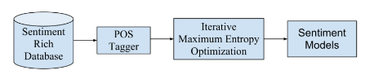

Datasets:
1. Amazon Product Reviwes → clase:1(malo)-5 (bueno); texto, la que usa rober
2.Pros and Cons database
3. Comparative Sentence Set database
4.YouTube audio database: audios de videos en lso que se dan opiniiones. Seleccionan sólo 28 (16+; 12-)(7female; 19 male); duracion media: 5 min/video
Sentiment Detection Playlist: URL → http://bit.ly/YAgoYU
Speech recognition: trained on a mixture of Swichboard and Fisher corpora(~500 hours of audio); MFCC for training. Acoustic model 4k tied-states and 16-mixture GMMs(Gaussian Mixture Models)
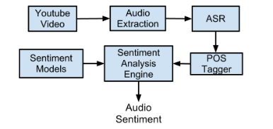

2016
Neurocomputing:
Fusing audio, visual and textual clues for sentiment analysis
from multimodal content
( http://sentic.net/multimodal-sentiment-analysis.pdf )

Department of Computing Science and Mathematics, University of Stirling, UK
b
School of Computer Engineering, Nanyang Technological University, Singapore
c
Media Laboratory, Massachusetts Institute of Technology, USA
d
School of Electrical
&
Electronic Engineering, Nanyang Technological University, Singapore
AUDIO FEATURES:
- MFCC
- SPECTRAL CENTROID
- SPECTRAL FLUX
- BEAT HISTOGRAM
- BEAT SUM
- STRONGEST BEAT
- PAUSE DURATION
- PITCH
- VOICE QUALITY
- PLP
USAN OPENEAR QUE ES UNA VERSIÓN ANTIGUA DE OPENSMILE CREO (ESCRITO EN C++)

2013:
YouTube Movie Reviews: Sentiment Analysis in an Audio-Visual Context
Martin Wöllmer, Felix Weninger, Tobias Knaup, and Björn Schuller, Technische
Universität München
Congkai Sun, Shanghai Jiaotong University
Kenji Sagae and Louis-Philippe Morency, University of Southern California
Databases for text: (lexical database of English):Online knowledge sources (OKS) in
natural language processing are data-
bases of linguistic knowledge that are
publicly available on the Internet:
- WordNet,
- ConceptNet,
- and General Inquirer
Database of written reviews of films: Meta- critic database
TEXT+AUDIO+VIDEO
Vídeos de Youtube y ExpoTV
ICT-MMMO (creadores)
ACOUSTIC FEATURES:
Usando openSMILE
audio set: 1941 features:
- 25 energy and spectral-related low level descriptors x 42 functionals
- 6 voicing-related LLD x 32 functionalss
- 25 deltas coefficients of the energy/spectral LLD x 23 functionals
- 6 delta coefficients of the energy/spectral LLD x 23 functionals
- 6 delta coffciients of voicing-related LLD x 19 funcionals
- 10 voiced/unvoiced durational fearutes
Para reducir el tamaño de estas caractrerísticas → cyclic correlacion-based feature subset selection (CFS)
usando cada training set de cada fold en su 3-fold cross-validation experiment.

78,74 y 71 acoustic features para los 3 folds.
VIDEOS:
facial tracking/detection → facila features → extrapolate a set of expressions and eye gaze directions using Okao Vision sw.
Se basan en la intensidad de la sonrisa que etiquetan del 0 al 100 y el gaze direction.
También usan 3D-head-pose tracer para mejorar el track comentado antes. Rate: 30Hz
Para audio y video features usan → BLSTM(Short-term memory recurrent neural nw)
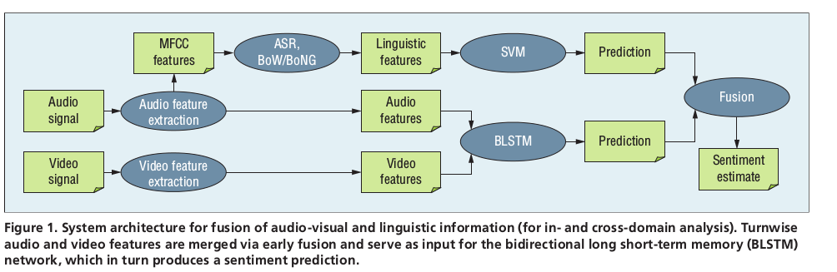
Final sentiment = 1.2*linguistic prediction+0,8*audiovisual score

Para el ICT-MMMO database: Dividen en 3 folds teniendo diferentes speakers in each fold y que el set de speakers son disjuntos para cada set.

2012
Sentiment Analysptis of Call Centre Audio
Conversations using Text Classification
Center for Informatics Science, Giza,Egypt
SOLO USAN EL TEXTO QUE EXTRAEN A PARTIR DE ASP SOBRE AUDIOS
All studies in the
field point to the pitch (the fundamental frequency) as the
main vocal cue for emotions recognition combined with vocal
energy obtaining an accuracy statistics ranging from 65% to
88%

Additional acoustic variables contributing to vocal
emotion signaling are Mel-frequency cepstral coefficients
(MFCC), Mel-based speech signal power coefficients,
formants and temporal features such as speech rate and
pausing

Other approaches include derivative
features such as LPC (linear predictive coding) parameters of
signal.
http://itl.nist.gov/iad/mig/publications/ASRhistory/index.html

2015

Multimodal sentiment analysis: Sentiment analysis using audiovisual format
Dept. of Computer Science & Dept. of Information Tech.; IGDTUW, Kashmere Gate, Delhi
Dept. of Computer Science ; G. L. Bajaj ITM, Greater Noida
The smiles, gazes, pauses, and voice pitch are identified as relevant features.Many new areas such as facial expression, voice intensity, pauses, pitch etc. are used in opinion mining from audiovisual formats.
Both audio and video signals are analyzed in parallel with the
same frame rate i.e., 30 Hz with the sliding window of 50
milliseconds. Emotions extracted from video like happiness,
sadness, boredom involve geometry based approach. The
emotions extracted from audio depend on the features like
pitch intensity, pauses, loudness etc. End of the statement is
detected by detecting any pause in audio frames. The polarity
is assigned to that statement spoken by the user on the basis of
both audio and video features. The overall polarity assigned to
product is the polarity assigned to maximum number of
statements in the video i.e., positive, negative or neutral.
Para imagen calculan features como separacióne entre el principio de las cejas, sonrisa...
AUDIO FEATURES:
- PAUSE:
- PITCH → it measures the cariation in voice during entire video
- INTENSITY → sound power
- LOUDNESS → Strength of voice
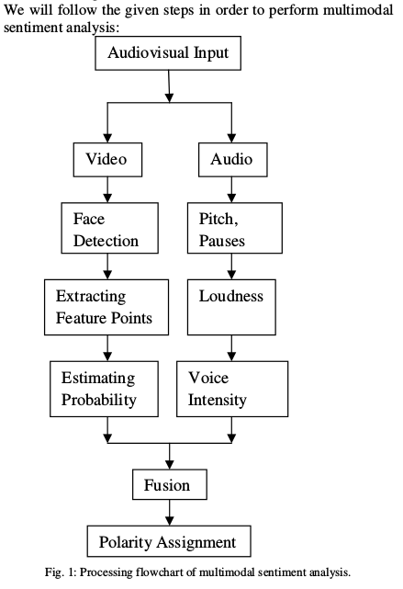
VIDEOS POSITIVOS: MUCHAS SONRISAS Y PAUSAS, NEGATIVOS: VOZ CON INTENSIDAD MÁS ALTA Y TRISTEZA EN LA CARA O ENFADO

FACE DETECTIONNSW:
- Face++ (http://www.faceplusplus.com/)
- FaceRect (https://www.mashape.com/apicloud/facerect)
EXTRACTING FEATURE POINTS:
- FaceSDK (https://www.luxand.com/facesdk/) : USAN 7U 8 DE LOS 66 EXTRAIDOS
EXTRACCIÓN DE AUDIO FEATURES:
- software PRAAT: Para PITCH and VOICE INTENSITY y LOUDNESS(amplitud de las ondas sonoras)
- Pauses: silencios que se estiman poniendo un umbral
NO PONE EL PORCENTAJE DE ACIERTO AL FINAL :(

2016
Affective Computing and Sentiment Analysis
Erik Cambria, Nanyang Technological University
Louis-Philippe Morency and col-
leagues combined acoustic, textual,
and video features to assess opinion
polarity in 47 YouTube videos.
Existing approaches to affective com-
puting and sentiment analysis fall into
three main categories: knowledge-
based techniques, statistical methods(deep learning),
and hybrid approaches.
NADA...LA MAYORÍA SOBRE TEXTO
2016
Building a Generative Model for Affective Content of Music
novel method has been proposed which
models the affective content as a Gaussian probability distribution
model called AEG (Acoustic Emotion Gaussian)
Valence and Arousal(incitación/agitación) system is one of the essential
system that is used to model emotions. The existing models
used emotional content of music fragment as a single point in
Valence and Arousal space and used average (mean) from
certain number of users without taking covariance into account.
There are several supervised machine based learning
classifiers for the sentiment classification task.-> best performance: ELM
Dataset: Dataset for Emotion Analysis using EEG and Physiological signals:para musica

2016
Fusing Audio, Textual, and Visual Features
for Sentiment Analysis of News Videos
Hacen un análisis de la tensión o no tensión que hay en lso vídeos
* Poria et
al. (2016) presented an innovative approach for multimodal
sentiment analysis which consists of collecting sentiment of
videos on the Web through a model that fuses audio, visual
and textual modalities as information resources.
A feature
vector were created in an fusion approach in an feature and
decision level, obtaining a precision of around 80%, repre-
senting a increase of more than 20% of precision when com-
paring to all the state-of-the-art systems.
Multimodal Features
In this work, multimodal features are organized into two
groups: (1) the audiovisual clues and (2) the sentiment
scores of textual sentences
Visual Intensity This feature was measured based on the
output margin, in other words, the distance to the separation
hyperplane of the classifiers used in Bartlett et al. (2006) un-
der a one-to-all approach, where it was used a Linear SVM
classifier for each of the modeled emotions (happiness, sur-
prise, aversion, contempt, anger, fear and sadness). The vi-
sual intensity of the emotion is computed for each frame of
the news video under analysis. In frames where no face was
detected, the system computes the emotion as Nonexistent.
Participants Field Size: ratio between the
recognition area of the largest face detected in the frame and
the current frame resolution to extract the proportion of faces
values of the participants in the camera placement.
Voicing Probability Shows the probability to have a tone
differentiation during the speech in the next moment.
Sound Loudness Sound loudness reflects the perception
of loudness of the sound wave by the human ear measured
in decibels (dB).
Fundamental Frequency Corresponds to the first har-
monic of a sound wave, this is the most influential frequency
for the perception of a particular sound and one of the main
elements for characterizing the voice

*In Step 3, the audio signal is processed by extracting the
corresponding acoustic data, also considering the speech in-
stants of individuals, that is, when speech occurs. To accom-
plish this, we use the openSMILE framework to extract the audio component of the spectrum and
obtain the prosodic features of loudness, voicing probability
and the fundamental frequency of the speech modulations
for each hundredth of a second these audio signals.

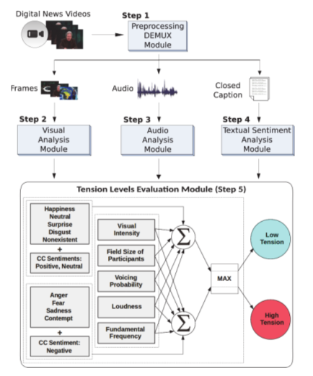

Bird Species Classification Using Visual and
Acoustic Features Extracted from Audio Signal
Para imágenes usa:
-LBP: Local Binary Pattern
-LPQ: Local Phase Quantization
-RLBP: Gray-Scale Level CO-occurrence Matrix (GLCM)
-Gabor filters
ACOUSTIC FEATURES:
- Rhytm Histogram: agrega valores de modulaciones de amplitud de 24 zonas críticas individuamlemnte obtenidas de un RP pasando a magnitudes de modulación para 60 freq. Entre 0,17 y 10 Hz
-Rythm Patters : segmentos de audio de 44 kHz con duración de 6 seg. Que se procesan usando Short-Time FT con ventana de Hanning de 1024 muestras y overlap del 50%
Luego, escala de Bark con 24 zonas de freq. Más
Se considera como una modulación de apmplitud lo de la escala de Bark → cepstrum

Posteriormente, este espectrograma se transforma a escala logaritmica dBs. Y aplicamos transformaciones psicoacusticas.-> Escala de Phon para incorporar curvas de tuido para calcular percepciones de ruido que son calculadas para calcular diferentes percepciones del ruido.
Se suaviza con filtros y obtenemos una matriz de 24*60.
-Statistical Spetrum Descriptor: Computar características de ruido en 24 zonas de la escala de Bark, análigamente a los RP. Luego medidas estadísticas son obtenidas para cada zona crítica, describiendo variaciones en cada una de las zonas estadísticamente. → captura info del timbre
SVM con 10-fold cross validation.
Para obtener espectrogramas: sofware Sox 14.4.1 (Sound eXchange),
FFT → redes neuronales
Time Delay Neural Network (TDNN) con autoagressive backprop
Sistema basado en el uso de MFCC parece que da muy buenos resultados
MFCC + Mean Frequency BW(MFB) y la densidad de espectro, clasificaciones con K-NN, SVM, distancias Kullbak-libler y Hellinger

Improved Multimodal Sentiment Detection Using
Stressed Regions of Audio
Mel Frequency Cepstral Coefficients
(MFCC) features are extracted at stressed significant regions
which are detected based on the strength of excitation. → GMM clasificador
In the literature MFCC, Linear Predictive Cepstral
Coefficients (LPCC) are the major spectral features used for
emotion recognition
Various acoustic cues such as Energy
of the excitation (EoE), loudness, strength of excitation (SoE),
instantaneous F0, and their combinations are explored to
study the emotion discriminating capabilities of the excitation
signal [4]. Strength of excitation of audio input is found
using Zero Frequency Filter (ZFF) method. Regions whose
strength of excitation fluctuates above and below 30% from
the mean strength of excitation referred as emotionally sig-
nificant regions [5] From the emotionally s
MFCC features are extracted and tested on GMM classifier.

NORMALMENTE COMBINAN CARACTERISTICAS OBTENIDAS CON OPENEAR CON SVM EN LA LITERATURACC de las stressed parts
AUDIOS USADOS: Each audio input is in .wav format, 16
bit, 16000 Hz sampling rate and a mono channel.
PROCESO DE OBTENCION DE LAS STRESSED REGIONS:
- Detecting Stressed Effected Regions: Utilizan zero freq. Filter method. La fuerza de la excitación es definida como la pendiente de la señal ZFF en cada epoch.
- Obtención de la ZFF:
  - EL time-varying low freq. Bias se elimina de la señal usando :
x(k) = s(k) − s(k − 1).
  - Luego esa señal se pasa por 2 resonadores ideales a 0 Hz:
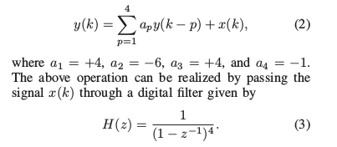

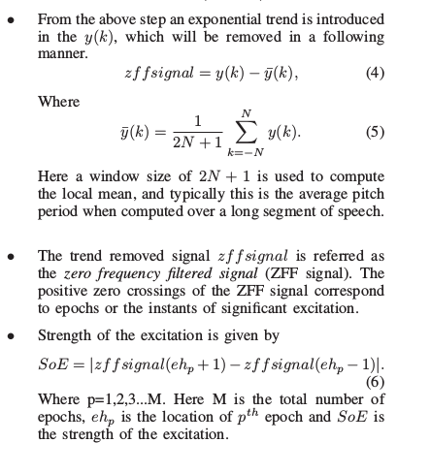

Deteccion de stressed significant regions: Se cogen trozos de 20ms y se obtiene la media del contorno smooth representando la intensidad de la curva de excitación. De aquí se obtiene un valor medio y si se pasa un 30% o está un 30% por debajo el SOE de ciertas partes se considera una region stressed.
Diferencia de precisión usando todos los MFCC o sólo en regiones stressed.
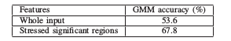

AUTOMATIC EMOTIONAL SPEECH CLASSIFICATION
IMPORTATE HACEN UN ANÁLISIS DE LAS CARACTERÍSTICAS QUE PUEDEN TENER MEJORES RESULTADOS.

